**LAPORAN**

**SISTEM BASIS DATA**

**TUGAS KELOMPOK**



**ANGGOTA KELOMPOK :**

**Hafizh Fathurrosy (L200210005)**

**Naufal Rafid Ardanu (L200210008)**

**Aldhyno Yoghatama (L200210014)**

**Muhammad Irfan Zahran (L200210016)**

**Muhammad Irfan Abidin (L200210021)**

**PROGRAM STUDI INFORMATIKA**

**FAKULTAS KOMUNIKASI DAN INFORMATIKA**

**UNIVERSITAS MUHAMMADIYAH SURAKARTA**

**TUGAS**

1. 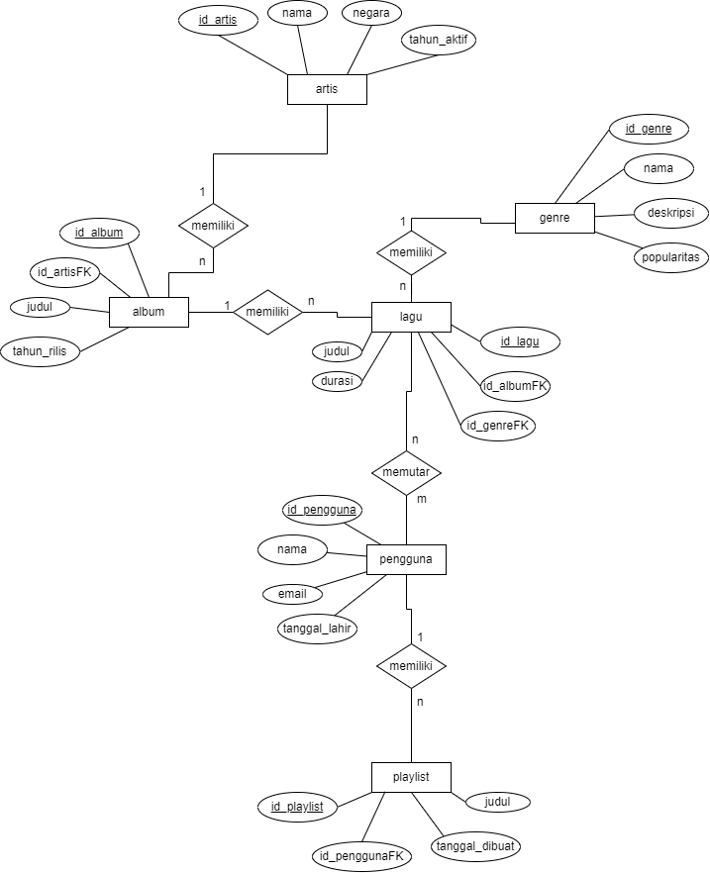**Buat ERD untuk database, minimal 6 entitas dan 4 atribut setiap entitas**
2. **Buat relasi setiap entitas nya**

* Artis – Album = 1:n (One to Many)
* Album – Lagu = 1:n (One to Many)
* Lagu – Genre = n:1 (Many to One)
* Lagu – Pengguna = n:m (Many to Many)
* Pengguna – Playlist = 1:n (One to Many)

1. **Konversi ke Tabel**

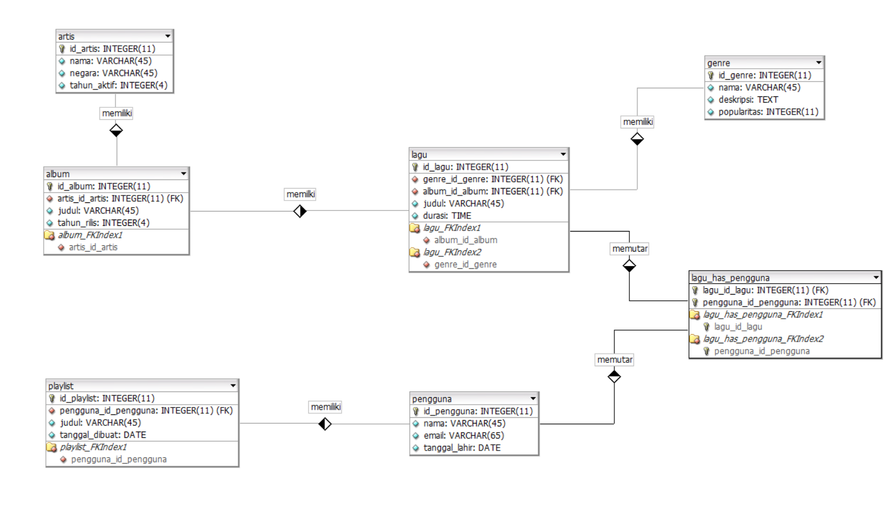

Tabel:

1. artis

|  |  |  |  |
| --- | --- | --- | --- |
| **Nama Field** | **Tipe** | **Panjang Karakter** | **Keterangan** |
| id_artis | INTEGER | 11 | PK, NOT NULL |
| nama | VARCHAR | 45 | NOT NULL |
| negara | VARCHAR | 45 | NOT NULL |
| tahun_aktif | INTEGER | 4 | NOT NULL |

1. album

|  |  |  |  |
| --- | --- | --- | --- |
| **Nama Field** | **Tipe** | **Panjang Karakter** | **Keterangan** |
| id_album | INTEGER | 11 | PK, NOT NULL |
| artis_id_artis | INTEGER | 11 | FK, NOT NULL |
| judul | VARCHAR | 45 | NOT NULL |
| tahun_rilis | INTEGER | 4 | NOT NULL |

1. lagu

|  |  |  |  |
| --- | --- | --- | --- |
| **Nama Field** | **Tipe** | **Panjang Karakter** | **Keterangan** |
| id_lagu | INTEGER | 11 | PK, NOT NULL |
| genre_id_genre | INTEGER | 11 | FK, NOT NULL |
| album_id_album | INTEGER | 11 | FK, NOT NULL |
| judul | VARCHAR | 45 | NOT NULL |
| durasi | TIME |  | NOT NULL |

1. genre

|  |  |  |  |
| --- | --- | --- | --- |
| **Nama Field** | **Tipe** | **Panjang Karakter** | **Keterangan** |
| id_genre | INTEGER | 11 | PK, NOT NULL |
| nama | VARCHAR | 45 | NOT NULL |
| deskripsi | TEXT |  | NOT NULL |
| popularitas | INTEGER | 11 | NOT NULL |

1. pengguna

|  |  |  |  |
| --- | --- | --- | --- |
| **Nama Field** | **Tipe** | **Panjang Karakter** | **Keterangan** |
| id_pengguna | INTEGER | 11 | PK, NOT NULL |
| nama | VARCHAR | 25 | NOT NULL |
| email | VARCHAR | 65 | NOT NULL |
| tanggal_lahir | DATE |  | NOT NULL |

1. playlist

|  |  |  |  |
| --- | --- | --- | --- |
| **Nama Field** | **Tipe** | **Panjang Karakter** | **Keterangan** |
| id_playlist | INTEGER | 11 | PK, NOT NULL |
| pengguna_id_pengguna | INTEGER | 11 | FK, NOT NULL |
| judul | VARCHAR | 45 | NOT NULL |
| tanggal_dibuat | DATE |  | NOT NULL |

1. lagu_has_pengguna

|  |  |  |  |
| --- | --- | --- | --- |
| **Nama Field** | **Tipe** | **Panjang Karakter** | **Keterangan** |
| lagu_id_lagu | INTEGER | 11 | FK, NOT NULL |
| pengguna_id_pengguna | INTEGER | 11 | FK, NOT NULL |

1. **Buat database pada mysql**

Tables :

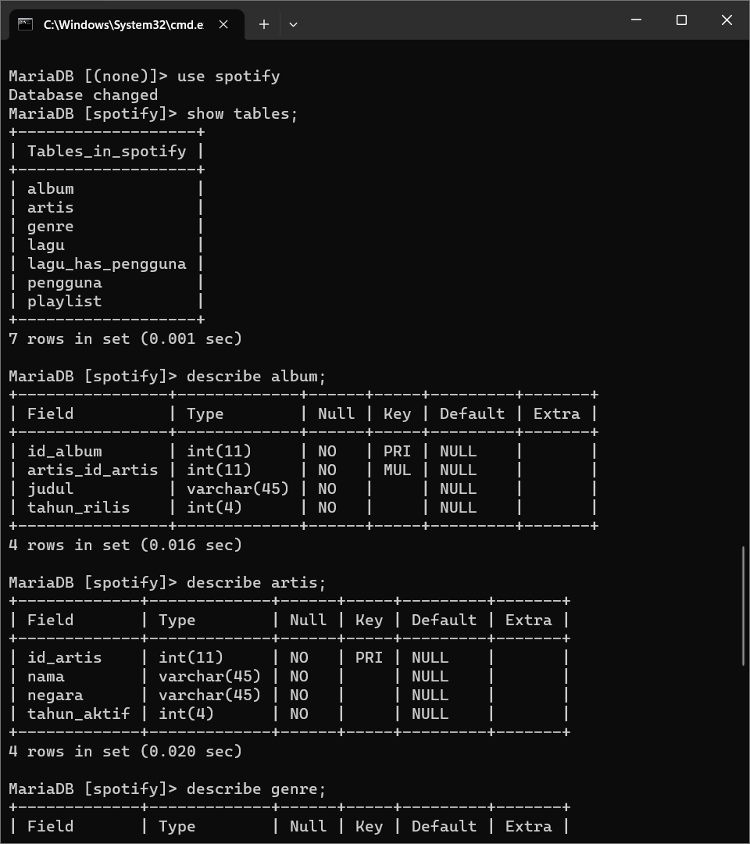

album :



artis :



genre :

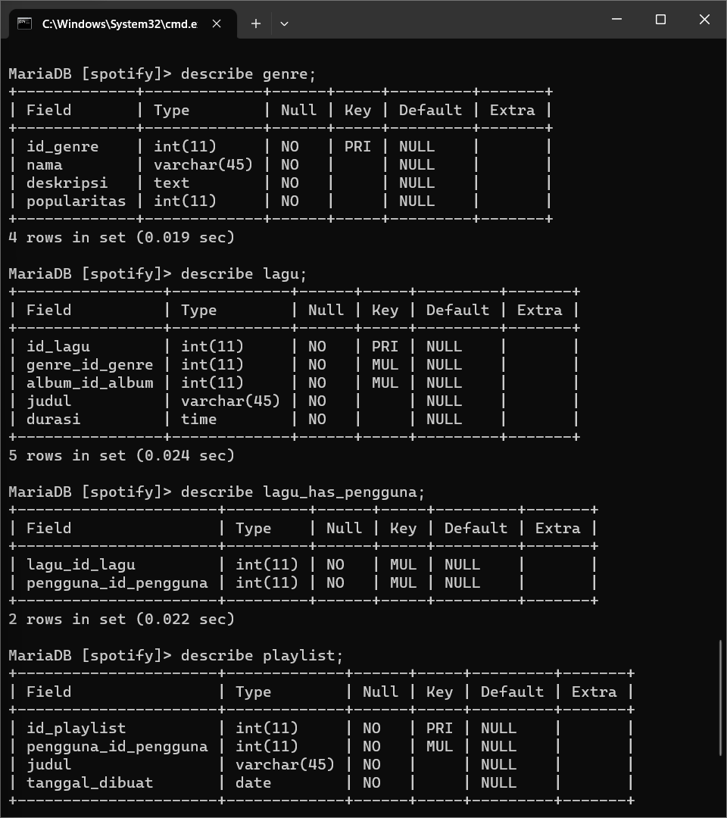

lagu :



lagu_has_pengguna :



pengguna :

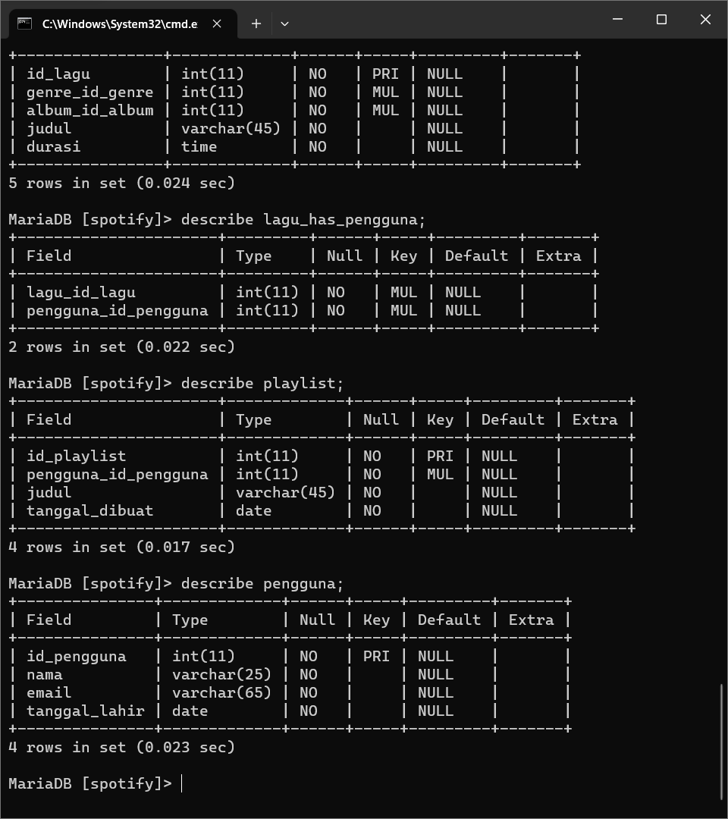

playlist :



1. **Isi 10 data setiap entitas**

album :

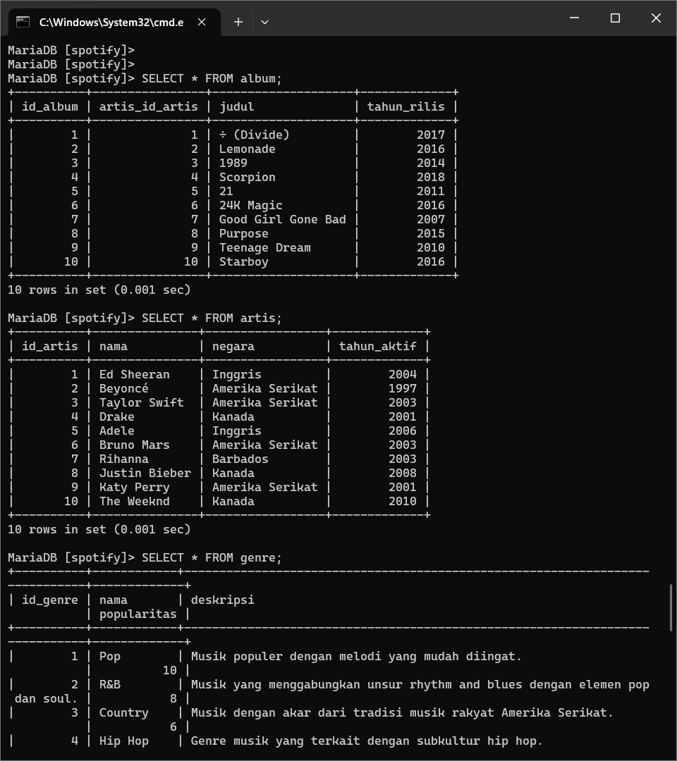

artis :



genre :

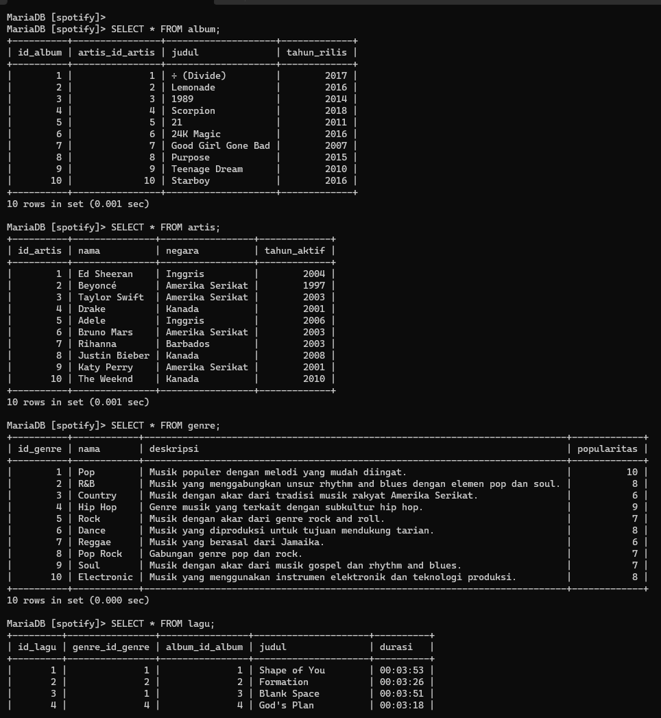

lagu :

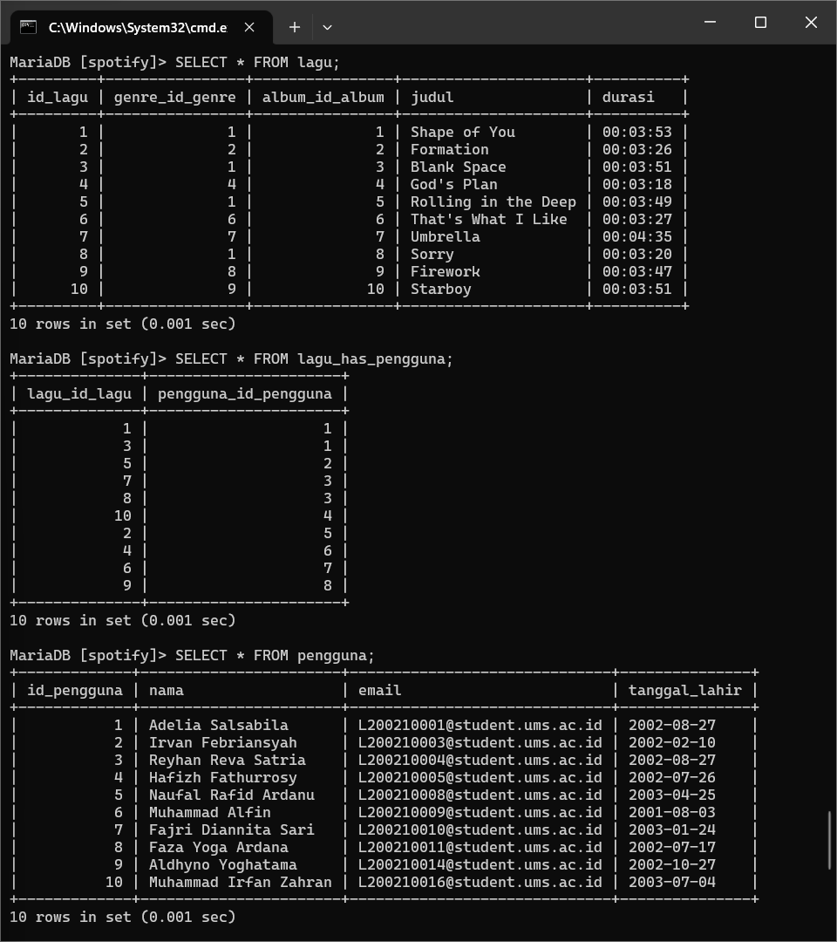

lagu_has_pengguna :



pengguna :



playlist :

